# IDX SmartFraming

IDX SmartFraming allows prospects/clients to search the Paragon database for listings via an agent’s and/or office’s web site. Once an agent/broker subscribes to IDX SmartFraming from their MLS, board or association, several links will be activated which they can incorporate into their web site. These links provide your clients with up-to-the-minute search results based on the data in Paragon. MLS rules dictate which data fields can be publicly searched on and displayed in reports.

Not all Associations have subscribed to IDX Smartframing. If your MLS has subscribed for this service, the IDX SmartFraming option will appear, as shown below, when you click Preferences.

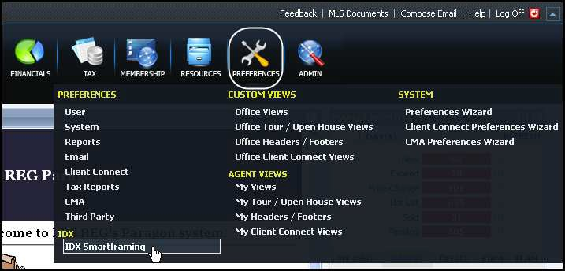To navigate to the IDX set up screen, click **Preferences** > click **IDX Smartframing**.

***Note:*** *In order for you to use IDX SmartFraming, your office must be an IDX Affiliate.*

The first time you enter the IDX SmartFraming module of Paragon, you will see the IDX Smartframing subscription page. After you review your Association’s IDX rules and fill out the appropriate paperwork, select the **I Agree** button, then click **Submit**. Your request to activate your IDX Smartframing account is sent to your Association for activation.

***Note:*** *Most associations will not activate agent/broker accounts and their links until the correct paperwork has been submitted and any associated fees are paid.*

Please contact your local association about the Smartframing rules and fees.

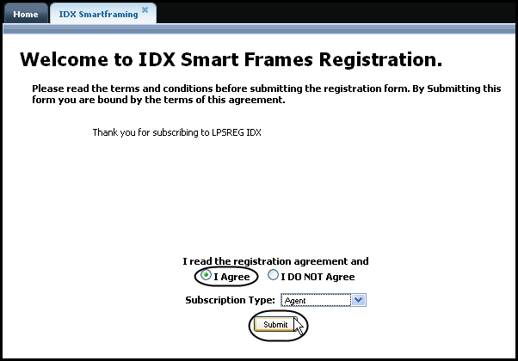

# Manage Contact Information

The following page opens after clicking **Submit**. The default content in your contact information is from your Agent Record and the Agent Image you uploaded into Preferences. You can edit this information.

Using the rich text editor, you can view, edit and save changes to your contact information.

Select the **COURTESY OF CONTACT** you want displayed (office phone number or office address) from the drop down shown in the image below.

The links at the bottom of the page should be sent to your webmaster so they can incorporate them into your website allowing your prospects to search the Paragon database from your web site.

***Note:*** *Your links will not be ready to use until the MLS, board or association activate your IDX SmartFraming account. You can check your account status at the top of the work pane.*

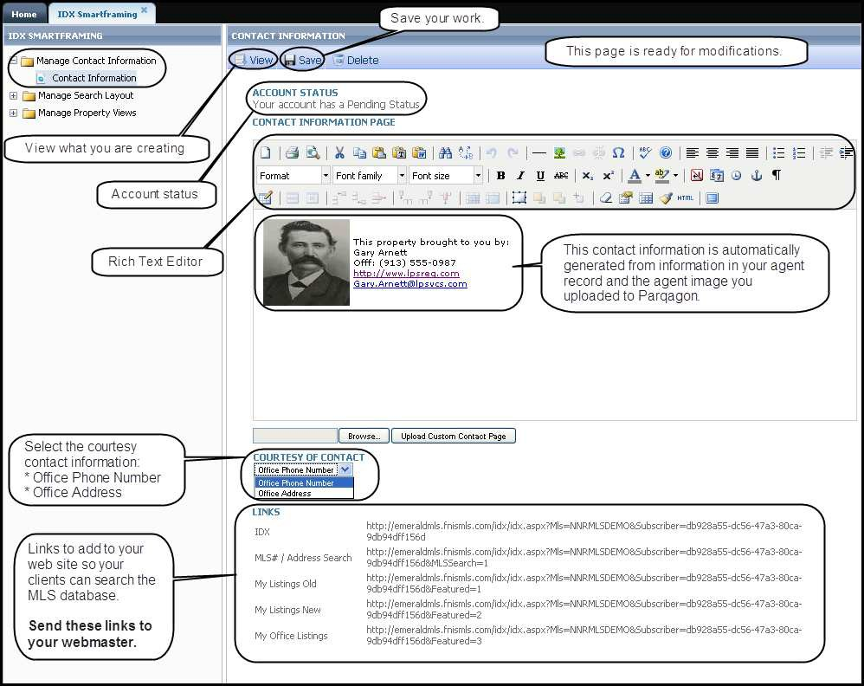

# Manage Search Layout

To manage the search criteria templates your prospects will use, click **Manage Search Layout** > click

**Search Layout** in the Left Navigation Pane.

**Note:** Customization of the Search Layout will depend on your local association’s rules and regulations.

If you have editing privileges for the search layout, you can move fields from the left side’s available field container and to right side’s utilized field container. You can set the position of the fields by moving fields up or down inside the utilized field container. The additional criteria field container gives your prospects an additional set of non-Primary search criteria with which to search. At the bottom of the Primary Search container, your prospects can click the link for the additional criteria.

When you complete customizing the search template, click **Save**.

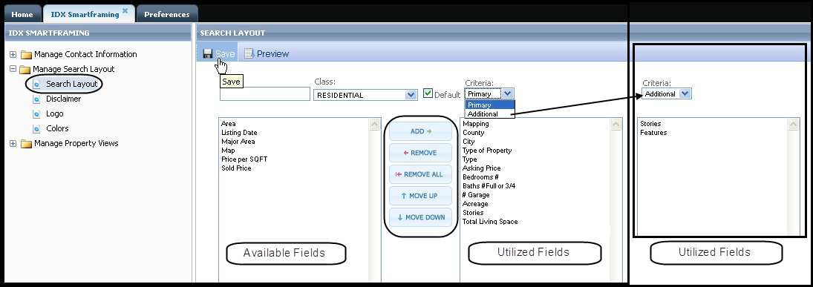

To see what your prospects will see when they search the Paragon database from your web site click

**Preview**. When you have finished previewing the search template, click **Close**.

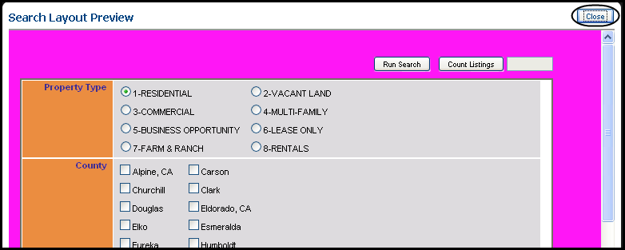

# Disclaimer

To manage the disclaimer your prospects will see, click **Disclaimer** in the Left Navigation Pane. The following window will appear. If your Association has granted editing privileges, you can edit the disclaimer. When you have completed the editing of the disclaimer, click **Save**. There is a disclaimer for both the Thumbnail views and Detail views.

***Note:*** *In most cases, the disclaimer is controlled by the Association and is not editable.*

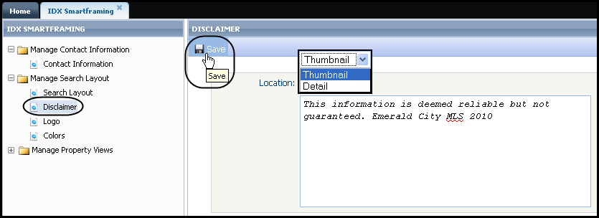

# IDX Logo

If the Association allows insertion of your own IDX logo, you can browse for your IDX logo when you click **Browse**. Browse to the location on your computer where you have your logo and double click the logo. This will fill the path for the logo in the field next to the Browse button on this page. Click **Save** to retain this logo as your IDX logo.

***Note:*** *In most cases, the IDX logo is controlled by the Association and cannot be changed.*

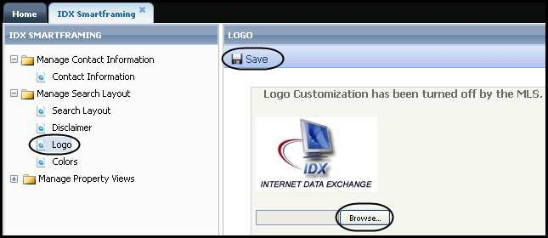

# Colors

You can change the color scheme of your default Search Criteria Template using the color tool.

You can also have multiple themes for your Search Criteria Template. To create additional themes, click

**Create New Theme** and select your colors. Give your theme a name and click **Save**.

The colors tool allows you to create/select a color scheme for your IDX SmartFraming search templates so they are complementary to your web site. As you change colors for the Page Background, Title Banner and Title Font, IDX SmartFraming displays the new color combinations.

There is a spectrum slide bar found in the middle of the Color Selector. Move the arrow on either side of the slider to select the basic color. Using the color square to the left of the slide bar, select the specific color you want.

When you have finished customizing your Search Criteria Template, click **Save**.

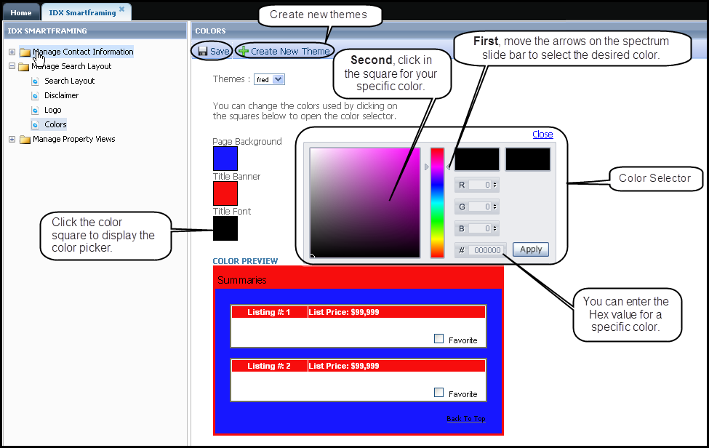

# Manage Property Views

Manage Property Views allows you to customize and/or create brochures for your prospects to view their search results they will see as they use your IDX SmartFraming.

# Default View Fields

Your MLS may have a default set of fields already assigned to each property class’ report views. If you have editing privileges, you can move fields from the left side’s available field container and to the right side’s utilized field container. You can set the relative position of the fields by moving fields up or down inside the utilized field container.

When you complete customizing the Report Views, click **Save**.

***Note:*** *Some Associations have turned off the editing of existing reports and/or the creation of new reports.*

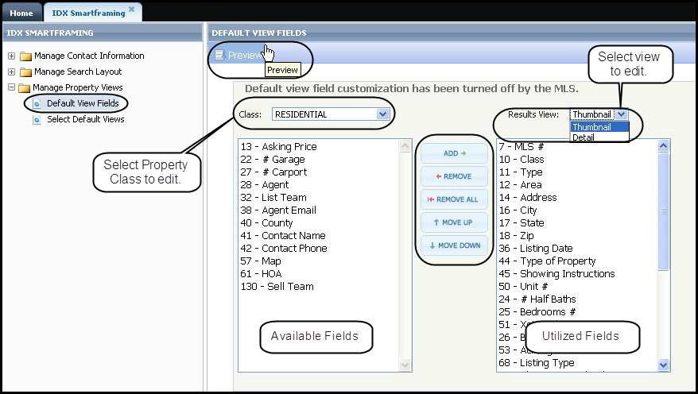

# Select Default Views

You can choose which view to use, if there are multiple views from which to pick. Using the dropdown boxes, select the view you want for the Thumbnail View and the Detail View. After you have made your selections, click **Save**.

