Here’s how to register for Paragon Academy.
Each step includes step-by-step screenshots.

If you are required to get a completion certificate, make sure to fill out the “Name” field with the name you wish to have printed on the Completion Certificate.

Step 1: Go to this website and register for an account.
https://blackknight.licenseschool.com/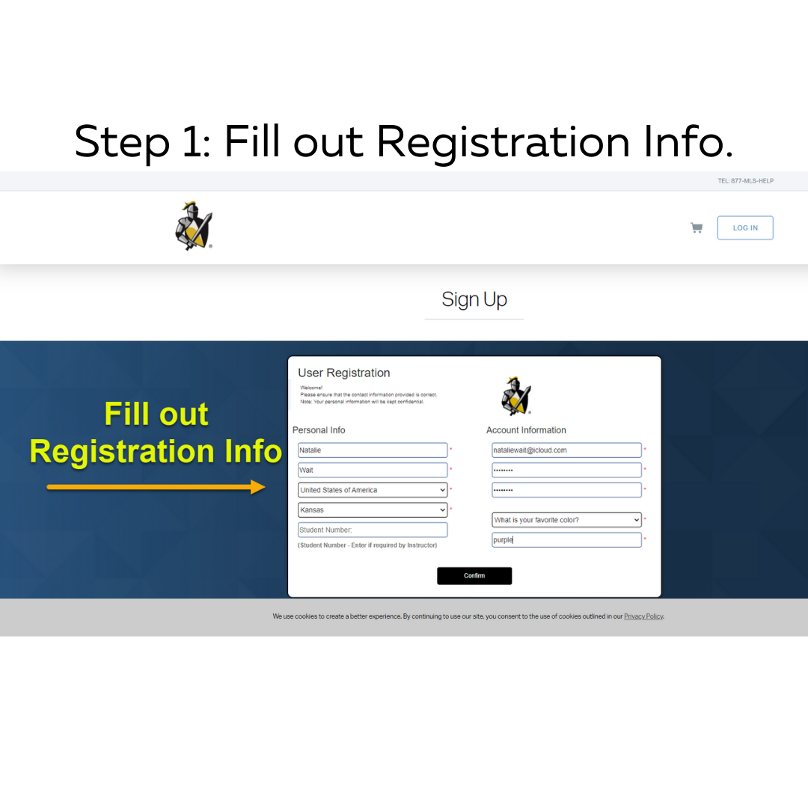

Step 2: Follow this path to log in to your account using the credentials you made during step one.

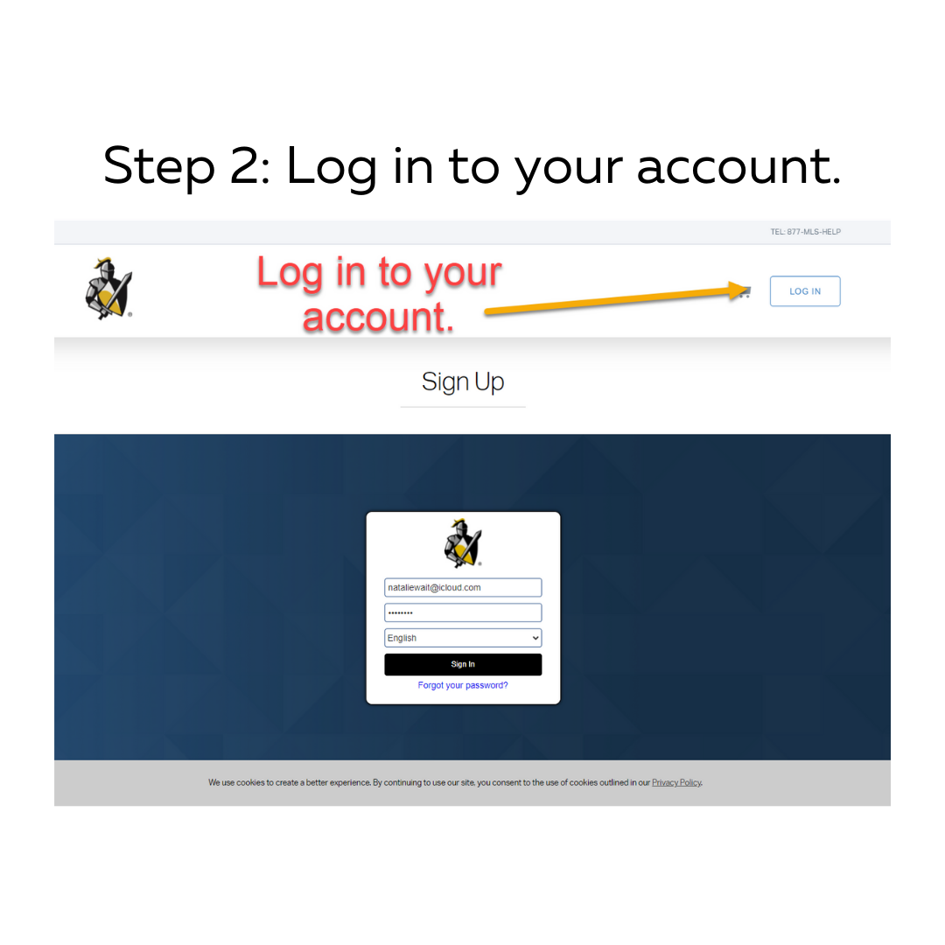

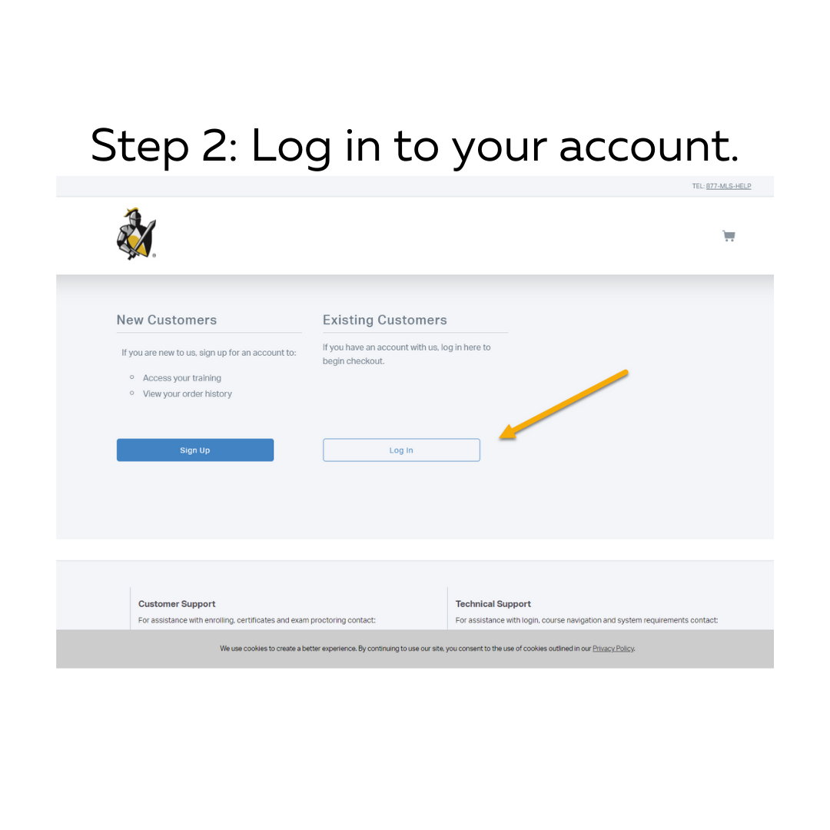

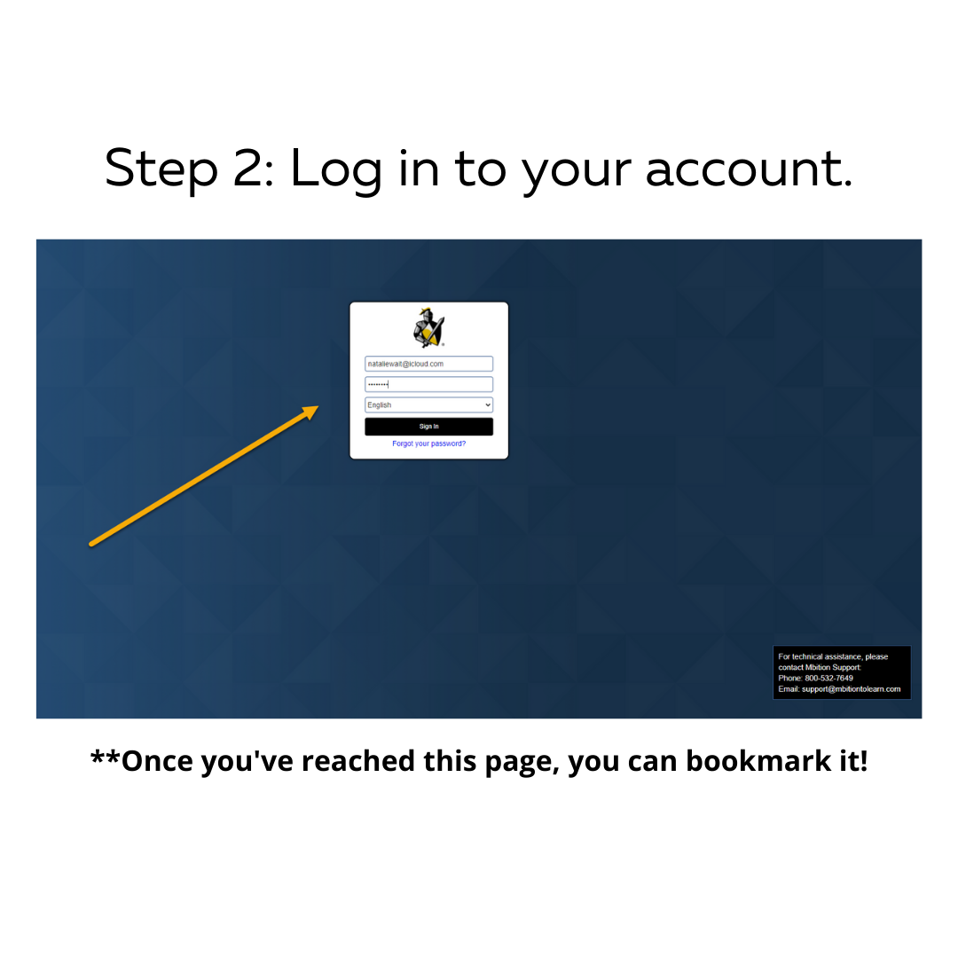

Step 3: Access your training.
You will need the access code that is listed on the Paragon Help Site.
- Find the access code at this Paragon Help Site URL:
https://help.paragonrels.com/Overviews/MLS_Paragon_Academy.htm
