Listing Activity Report Definitions
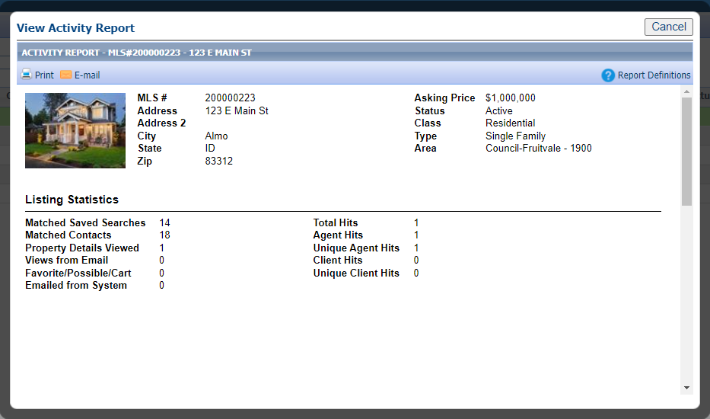
Matched Saved Searches: Each time the listing is included in the result set of a saved search this value is incremented.
Example: Matched Saved Searches: 14

Matched Contacts: Each matched saved search will be evaluated to determine the contact to which it is assigned. The total number of contacts whose saved searches include the listing as a match will be reported.
Example: Matched Contacts 18

Property Details Viewed: Each time the listing is viewed in a single listing detail view in any Paragon application, this value is incremented.
Example: Property Details Viewed 1

Views from Email: The number of times a link was clicked or tapped inside an email sent from Paragon.
Example: Views from Email 0

Favorite/Possible/Cart: The number of times the listing has been marked “favorite” and/or “possible” and/or added to a Listing Cart.
Example: Added to Listing Cart 0

Emailed from System: Each time the listing is emailed from the Paragon application this value is incremented. Email activities include automatic notifications for prospecting purposes and listings selected to be emailed on an ad hoc basis.
Example: Emailed from System 0

Total Hits: This value will be incremented each time a listing is viewed in a single listing detail view within Paragon, Client Connect or emailed report views. The Hit Count data may be blocked by field security. If this is the case Listing Activity Tracking data (Listing Detail Views) will be substituted in lieu of hit count data. This data represents the complete total number of hits on the listing to date and should be the sum of the Agent Hits and Client Hits combined. Note: all client hit counts or detail views are limited to one per unique IP address per 24 hours.
Example: Total Hits 1

Agent Hits: Each time an agent views a listing in Paragon in a single listing detail view this value is incremented. If the agent hit count field is disabled by field security or configuration, listing activity tracking data will be substituted.
Example: Total Agent Hits 1

Unique Agent Hits: The agent hits are evaluated by Paragon user ID to determine how many unique agents viewed the listing. If the agent hit count field is disabled by the field security or configuration, listing activity tracking data will be substituted.
Example: Unique Agent Hits 1

Client Hits: Each time an individual views a listing in a BKMLS application outside of Paragon, this value is incremented. Client hits are limited to one per unique IP address per 24 hours to discourage inflated listing activity reports. If the client hit count field is disabled by field security or configuration, listing activity tracking data will be substituted.
Example: Client Hits 0

Unique Client Hits: The client hits are evaluated by IP address to determine how many unique clients viewed the listing. If the client hit count field is disabled by field security or configuration, listing activity tracking data will be substituted. Client hits are limited to one per unique IP address per 24 hours to discourage inflated listing activity reports.
Example: Unique Client Hits 0

